**NAME: 1. Tanish Shetty (**[**shettytanish02@gmail.com**](mailto:shettytanish02@gmail.com)**)**

**2. Vidhi Vaidya**

# DriveSys – Cab Booking System

*Description:*Booking a cab and reaching your destination has become much a more fun and interactive experience. Our System helps Customers book cabs online rather than using the traditional method of manual reservation.

**Customer side:**It will be easier for the user to access the driver’s details such as:

1. Driver Name
2. Contact No.
3. Driver Rating/Review

**Driver side:**It will be more convenient for driver to view customer details like:

1. Address
2. Name
3. Contact

Cab booking has become an invaluable necessity in this day and age as availability of regular taxis or rickshaws is unpredictable and the comfort level provided by other modes of public transport is unsatisfactory. Hence we feel the need for a proper cab booking system which is why we have chosen to implement this topic.

## *A Brief Analysis:*

Within the booking system, Customers need to have an account which is backed up by their email address and mobile no. They also have a username, name, password, Home Address. The Booking Company shall have a customer unique ID to separate each customer.

1. **Customers:** UID, name, username, password, email, mobile no., Address, Mobile No.
2. The **Driver** will have a UID from the Company, their Driver’s License No., Name, Phone No., Address and a Rating.
3. The **Car** used by the Driver shall have its License No., Model No., Model Name, Mileage, Capacity.
4. The **Journey**shall contain – pickup point, destination, amount, pickup time, drop off time, distance, rating.
5. The **Cars** shall come from their respective Companies with their own UID, Name and Name of Car Model sent.
6. The **Administrative Office**shall have its UID, phone no. For any Customer Complaints and an Inquiry No. for the Driver.
7. **Employees** in the Administration shall have their own UID, name, designation (Customer complain or driver inquiry)

**ER DIAGRAM**

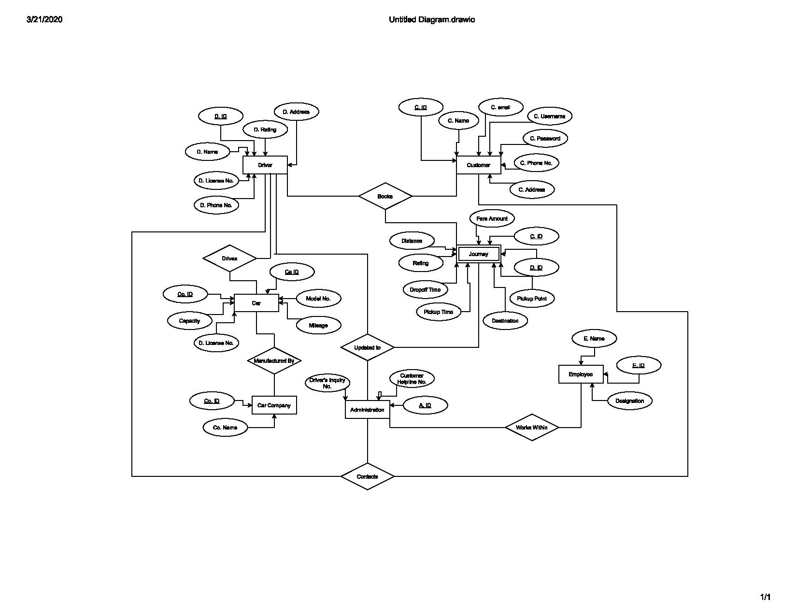

Google Drive Folder Link for Videos:

https://drive.google.com/open?id=1UAlaCds8g2_kFJl7j3CMEyGefv_eLvIB